Warning
1 It is a high-precision product, do not fall or crash.
2. Do not expose the unit to strong magnetic objects, such as magnet and electrical motor. Avoid strong radio waves. Strong magnetic fields may cause the products breakdown or images and sounds damage.
3 Never leave the products exposed to high temperatures and direct sunlight.
4 Please choose branded Micro SD card. Neutral cards are not guaranteed to work normally.
5 Do not place Micro SD card near strong magnetic objects to avoid data loss.
6 In case of overheating, smoke, or unpleasant smell in the process of charging, unplug your device immediately to prevent fire hazard.
7 While it is charging, keep the product out of children’s reach. Power line may cause children accidental suffocation or electric shock.
8 Keep the device in cool, dry and dust-proof places.

Preface

This product is a high-definition digital motion video recording device tailored to market demand. It has a variety of industry-leading features including digital video recording, photo shooting, audio recording, video display and detachable battery, which makes it perfect for vehicle data recording, photo-shooting, outdoor sports, home security, deep-water probing, etc., allowing you to film at anytime, anywhere. And it has a variety of patents.

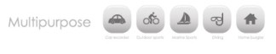

Product Features

>A water-resistant casing that allows you to film fascinating water sports; water-resistant up to 30 meters under water
>High definition screen that displays and replays fascinating videos recorded
>Detachable battery that is easy to replace and prolongs your camera’s service life
>Video recording while charging
>Video recording with battery
>14-megapixel HD wide-angle lens
>HDMI HD output
>Web camera
> Support storage cards up to 32GB maximum
> Multiple video recording formats: 1080P 720P WVGA
> Recorded in MOV format
>Multiple photo shooting modes: Single shot, Snapper
> Video encryption enabled
> Mini appearance, diversified colors available

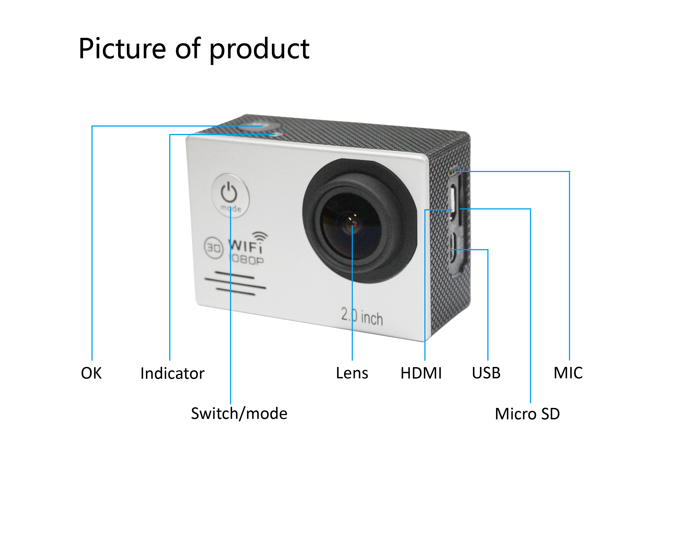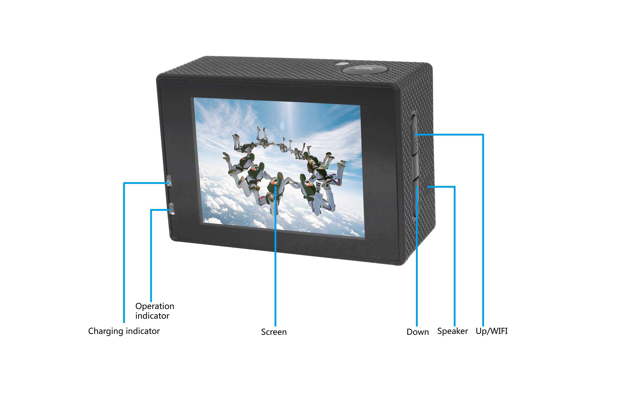

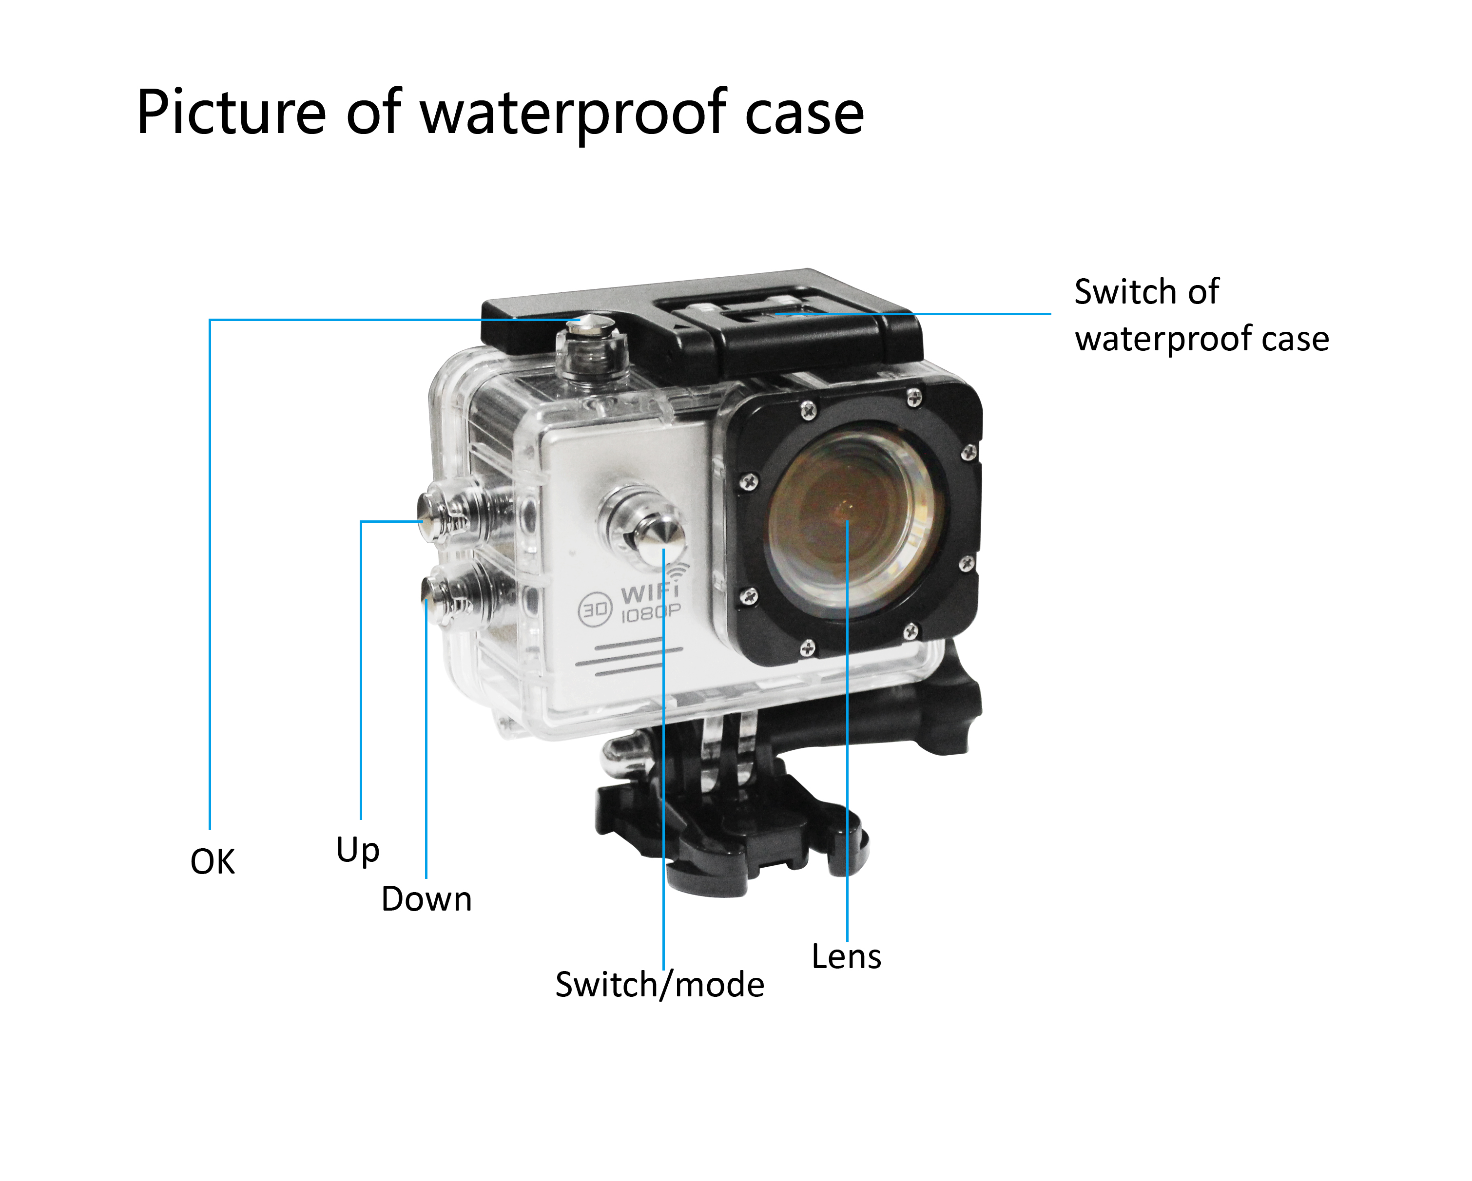

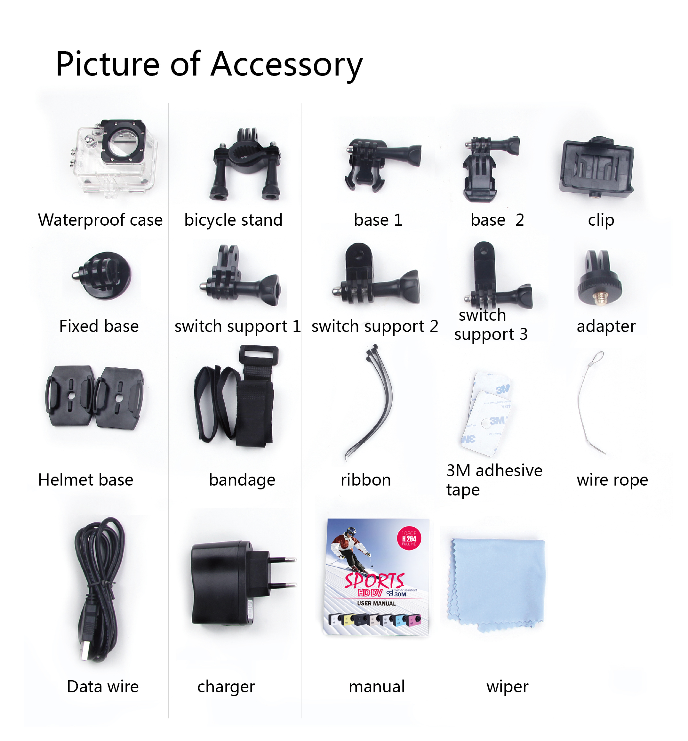

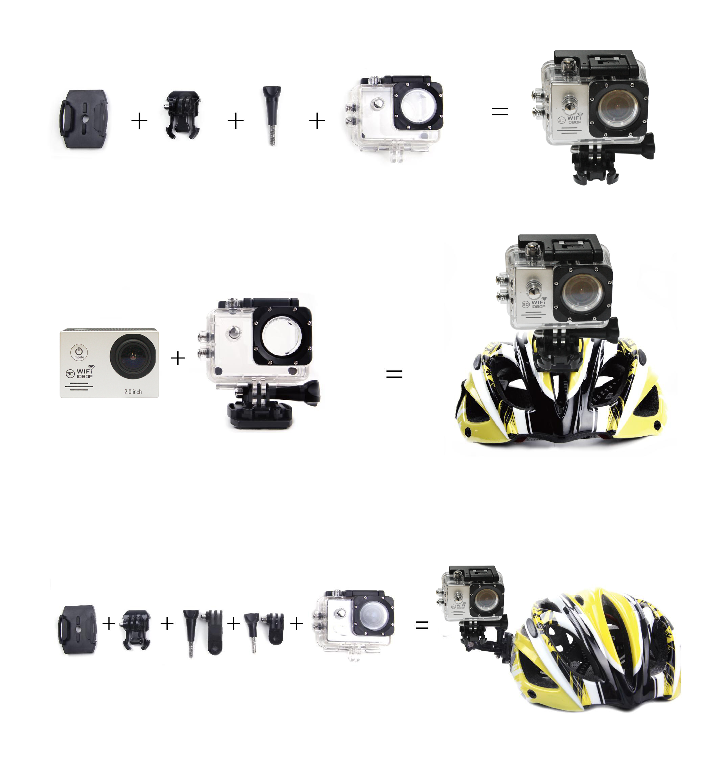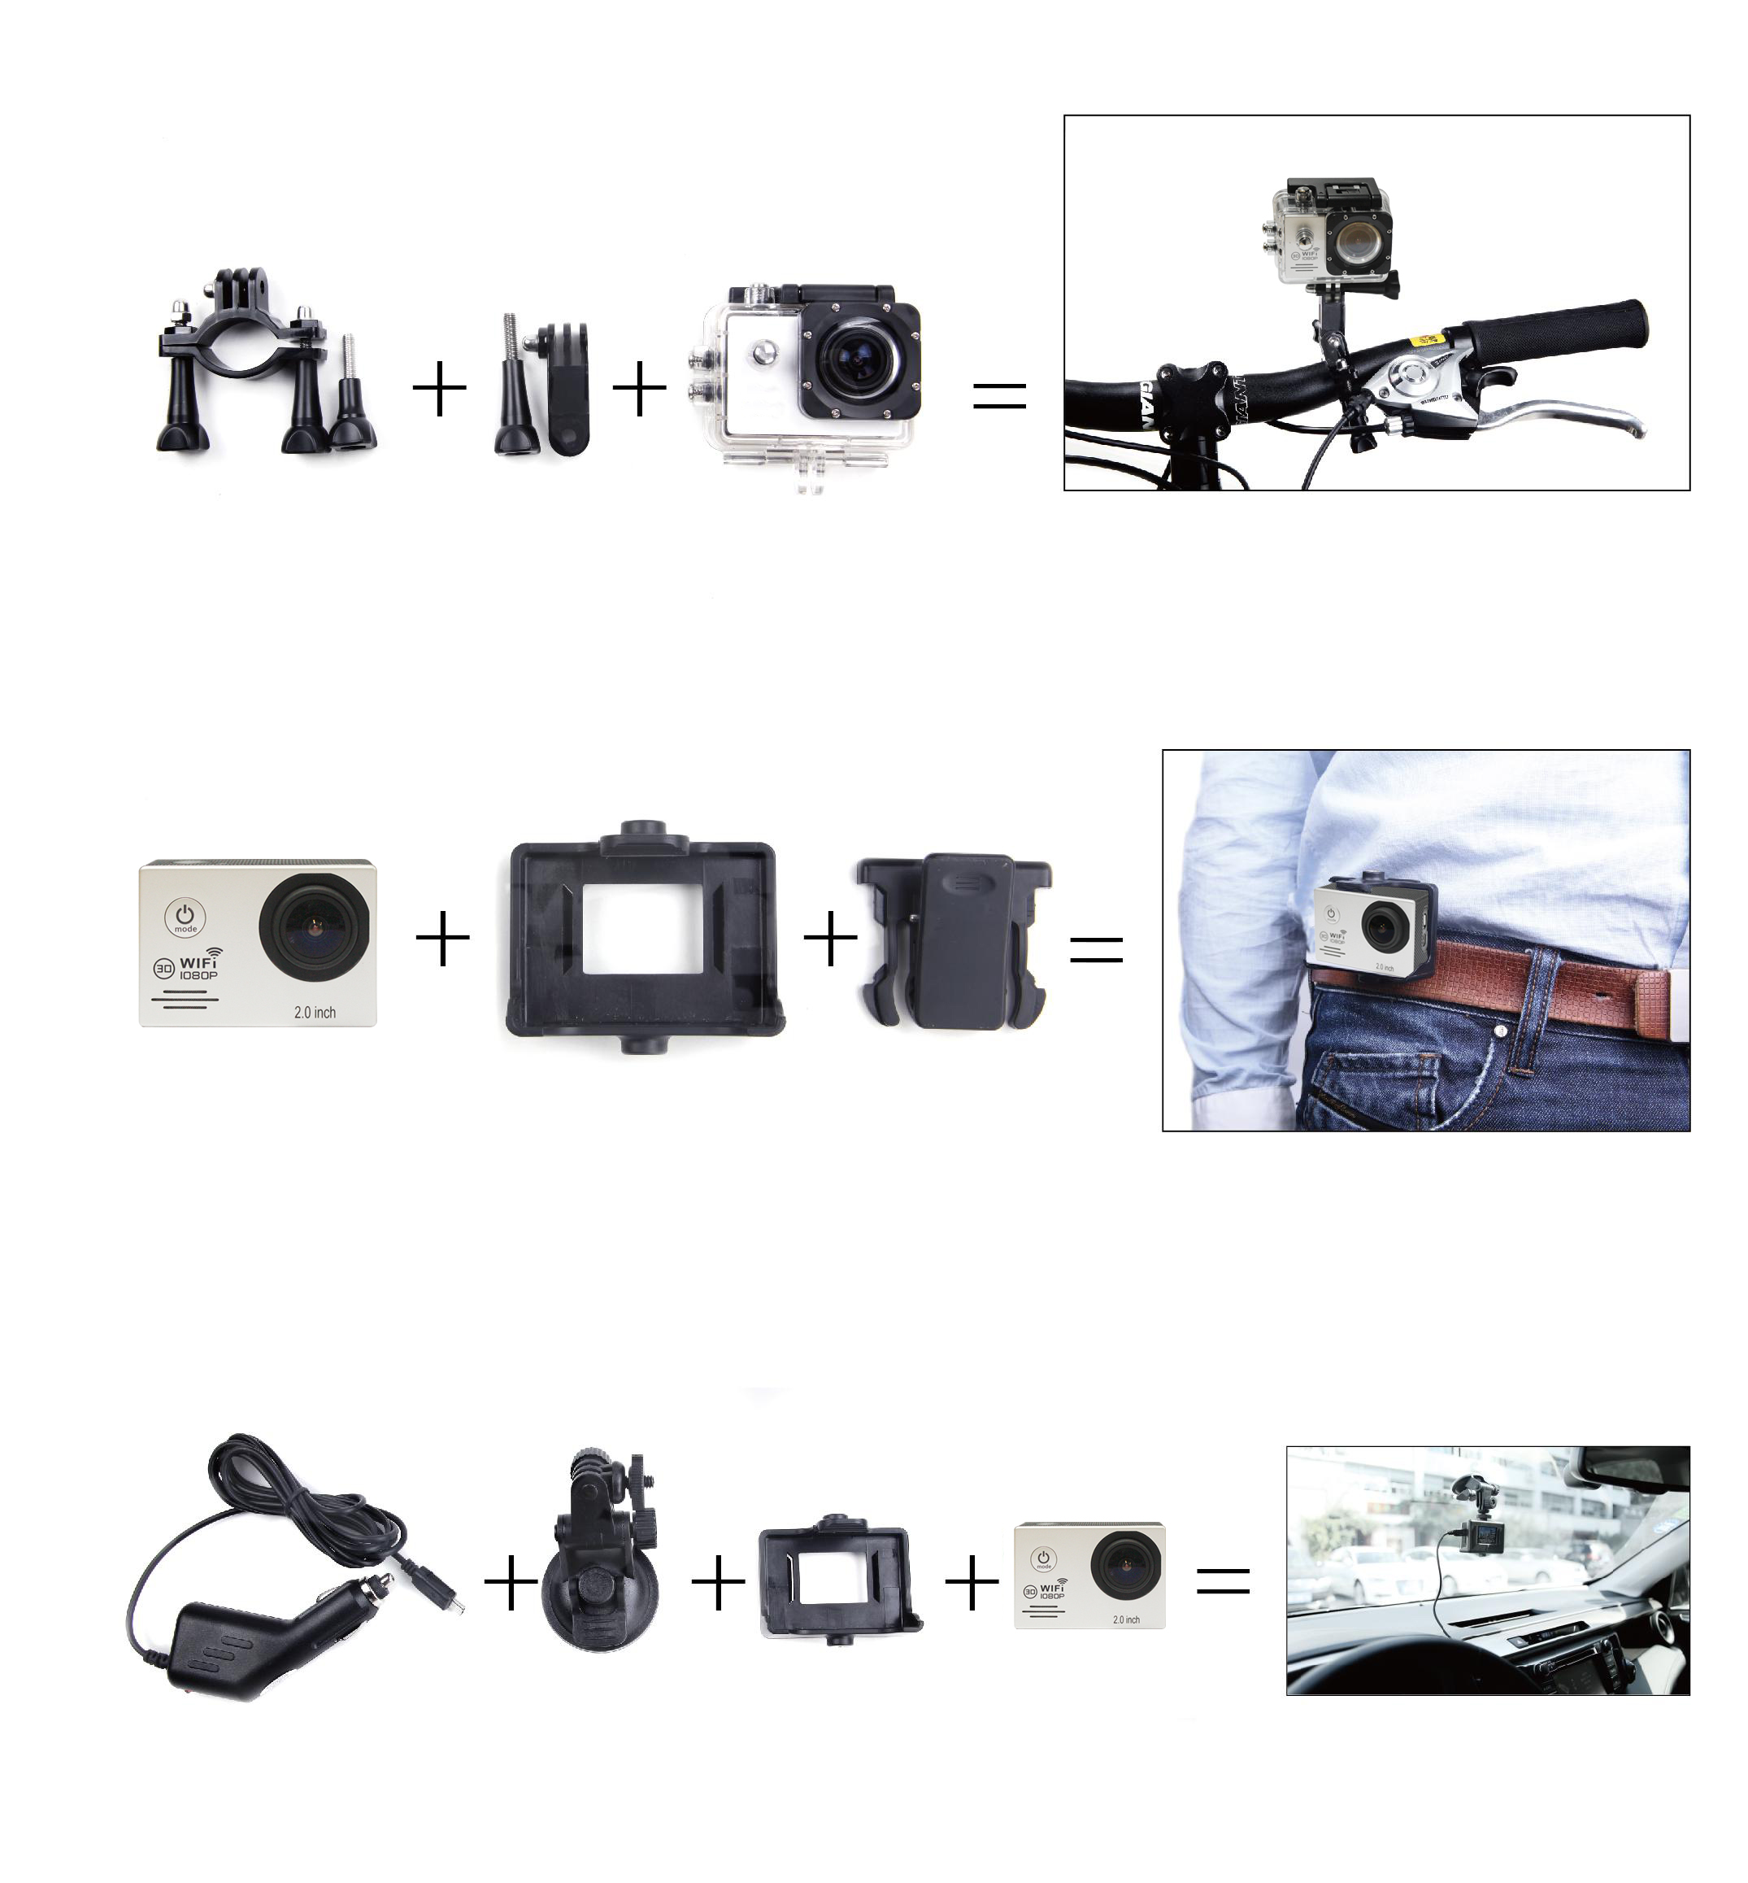
- Inserting Micro SD Card
Note: Please choose branded Micro SD card and format it on computer before use. Neutral cards are not guaranteed to work normally.
- Installing and removing batteries
A | Press on battery cap to open it.
B | Correctly install battery into camera as indicated by +/- symbols and direction of arrows marked on battery until it’s in place.
C | Battery Gauge: Please refer to diagram.
D | Remove Battery: Open cap to take battery out.
- Charging
A | Charging can be done by either connecting SJ5000 to computer or power adaptor.
B | Charge SJ5000 on vehicle by connecting it to car charger.
C | SJ5000 can record video while charging (Switch into Vehicle-mounted Mode in “Menu”）
D | Charging of SJ5000 can be done even when it’s powered off.
- Switching camera on and off
A | Press and hold power switch for 3 to 5 seconds to turn it on / off.
B | Switch it on and off by turning display screen on and off.

- Mode Switching
Switch between video recording / photo shooting / playback / menu by pressing “Power On-Off” button.
 recording mode, while  photo shooting mode. Symbols are displayed on top of screen. Refers to the function of video playback, and the last one is system settings.

6. How to record videos and configure recording setting

1. | Video Recording  Switch to recording mode and there’ll be an icon in the upper left corner of the screen. Press OK to start recording and the icon in the upper left corner will start to flash. Press “OK” again if you want to stop and the icon will disappear.
2. | Photo shooting & Settings  Switch the camera on and press “Mode” to select “Photo shooting Mode”, there’ll be an icon in the upper left corner of display screen and the camera is in photo shooting mode. Press “OK” to take photos.  Shooting Pattern: Single shot / Self-timer (2s/5s/10s) / Continuous Shooting

3. File Storage & Playing
After you are done recording, use a USB cable to export the videos onto a computer to play. Or you can take the Micro SD card out and access the image data with a card reader.

7. WI-FI connection
- This product can connect a mobile phone with android or IOS system or a panel computer via WIFI, the operation steps are as following:
- Install” youmera “ software on a mobile phone or a panel computer(you can search and download on Google Play for android system, or search and download on APP Store for IOS system.
- After power on, press WIFI key on the camera, WIFI icon displays on the screen, Sports DV_WIFI displays.
- Enable WIFI on a mobile phone or a panel computer, search WIFI account Sports DV_WIFI for the camera, then connect, and the initial Password ” 12345678” will display on the screen.
- When WIFI connected, WIFI Connection Ready displays on the screen,
- After “youmera” software operates on a mobile phone or a panel computer, images recorded by the camera will be real-time displayed on a mobile phone or a panel computer. You can operate via related icons related to the software or set function parameters of the camera
- WI-FI password change
A. Power on and enter WIFI setting menu, the password can be set as per your requirement.

Liquid Crystal Display (LCD) | 2.0LTPS
Lens | 170°A+ HD wide-angle lens
Language Options | English / German / French / Spanish / Italian
 | Portuguese / Chinese Traditional / Chinese Simplified / Japanese / Russian
Resolution of Videos Recorded | 1080P (1920*1080 ) 30FPS  720P (1280*720) 60FPS  VGA ( 848*480) 60FPS  QVGA (640*480) 60FPS
Video Format | MOV
Compressed Format of Videos | H.264
Resolution of Photos | 12M / 8M / 5M
Storage | Micro SD
Shooting Mode | Single Shot / Self-timer (2s / 5s / 10s / Continuous Shooting
Frequency of Optical Source | 50Hz / 60Hz
USB Interface | USB2.0
Power Source Interface | 5V1A
Battery Capacity | 900MAH
Power Dissipation | 400mA@4.2V
Recording Time | 1080P/ About 70 minutes
Charging Time | About 3hours
Operating System (OS) | Windows XP/VistaorAbove/Win7/Mac os
Dimension | 59.27*41.13*29.28

Note: Specifications could be subject to modification due to upgrading or updating. Please regard the actual product as the standard form.


